**59. Using Version Range**

--- tree

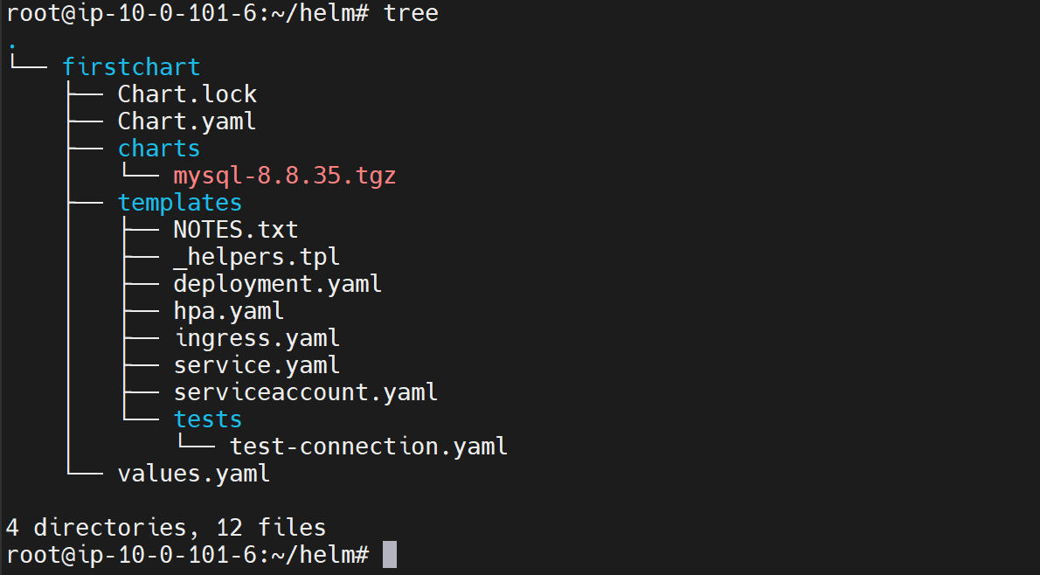

--- cat Chart.yml

dependencies:

  - name: mysql

    version: ">= 8.8.0 and < 9.0.0"

    repository: "https://charts.bitnami.com/bitnami"

--- What is the advantage of using these ranges instead of exact version?

If we are sure that our application, the chart that we are trying to deploy, which is using this dependency, can work with the latest version of the dependency.

--- Let's say today it is 8.8.6 and, in a month, or two they are releasing 9.0.0 and we are sure that our application will be OK to work with 9.0.0, if we define this range, even when we do a install in the future after two months, instead of we coming to this file and manually changing the version to whatever version we want, if we simply specify this range like this automatically when a future installation is done, Helm will pull this latest version whenever it is available in the repository, that is

the advantage of having Ranges.

**~, ^ (special operators)**

**^ (Carrot symbol)**

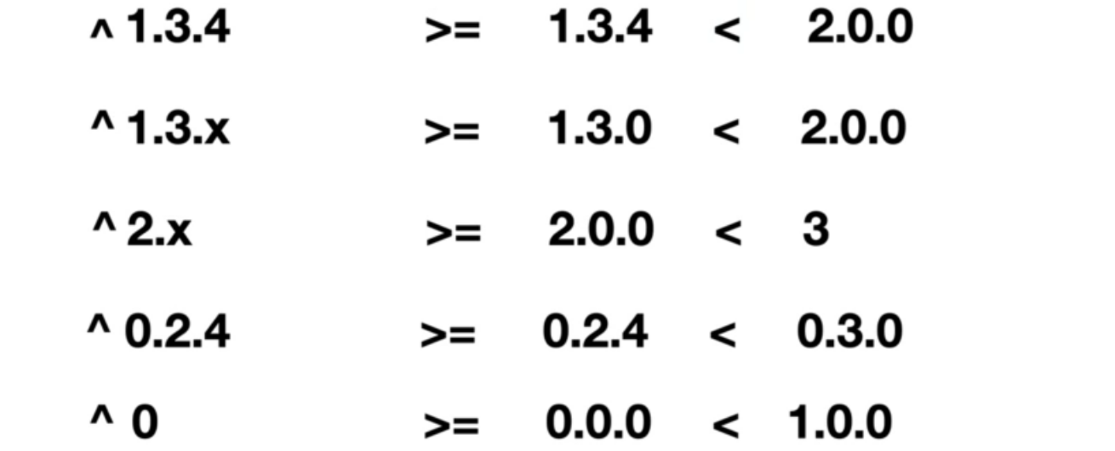

--- **note** – if you give like this ^ 1.3.4 then it will go to the next major version. You can also use x.

--- ^1.3.x – if you give like this then it will treat as 1.3.0

--- ^2.x – if you give like this then it will treat as 2.0.0

**~ (Tild symbol)**

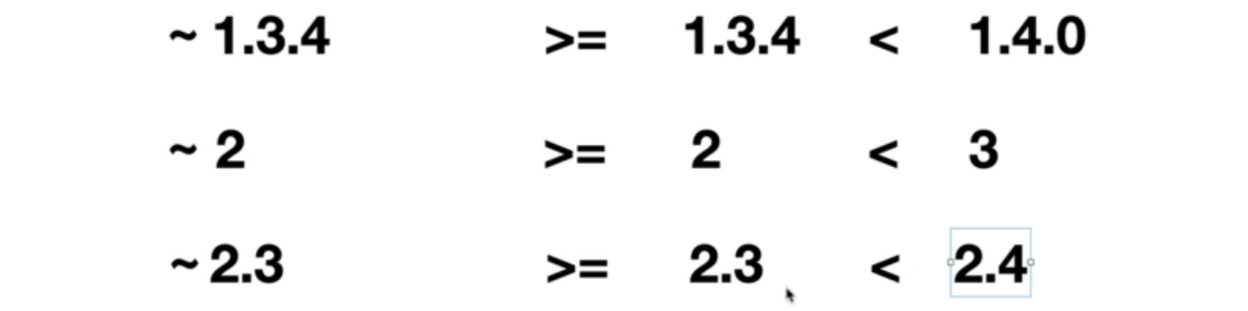

--- **note** – it will go for the next minor version.

**Chart.lock**



--- cat Chart.lock

dependencies:

- name: mysql

  repository: http://charts.bitnami.com/bitnami

  version: 8.8.35

digest: sha256:1a7e56bddb00b75ebea03bd571dbcf1298ee16518964229e7815b15c6f68ca63

generated: "2022-09-17T16:18:47.590127412Z"

--- **note** - This chart.lock will be generated by helm and it will have the exact version which it is pulling, although you specify a range here. the chart.lock will be used across environments.

--- so, once we do a helm update dependency, Helm generates a chart.lock.